

Practices for Secure Software Report

Table of Contents
Document Revision History 3
Client 3
Instructions 3
Developer 4
1. Algorithm Cipher 4
2. Certificate Generation 4
3. Deploy Cipher 4
4. Secure Communications 4
5. Secondary Testing 4
6. Functional Testing 4
7. Summary 4
8. Industry Standard Best Practices 4

Document Revision History

Version | Date | Author | Comments
1.0 | March 1st, 2026 | Max Rodriguez | sleepy

Client



Instructions

Submit this completed practices for secure software report. Replace the bracketed text with the relevant information. You must document your process for writing secure communications and refactoring code that complies with software security testing protocols.

- Respond to the steps outlined below and include your findings.
- Respond using your own words. You may also choose to include images or supporting materials. If you include them, make certain to insert them in all the relevant locations in the document.
- Refer to the Project Two Guidelines and Rubric for more detailed instructions about each section of the template.

Developer
Max Rodriguez

Algorithm Cipher

I recommend using SHA-256 as the encryption algorithm cipher. SHA-256 is part of the SHA-2 family and is supported by the Java Security Standard Algorithm Names list. It is widely used and is not vulnerable to known collision attacks like older algorithms such as MD5 or SHA-1.

SHA-256 is a secure cryptographic hash function that creates a fixed 256-bit hash value. Avoiding collisions means that two different inputs should not produce the same hash value. This is important because if collisions are possible, an attacker could create a fake file that has the same checksum as the real file. SHA-256 is considered secure and resistant to collision attacks, which makes it a good choice for verifying downloaded files and public keys.

Certificate Generation
Insert a screenshot below of the CER file.

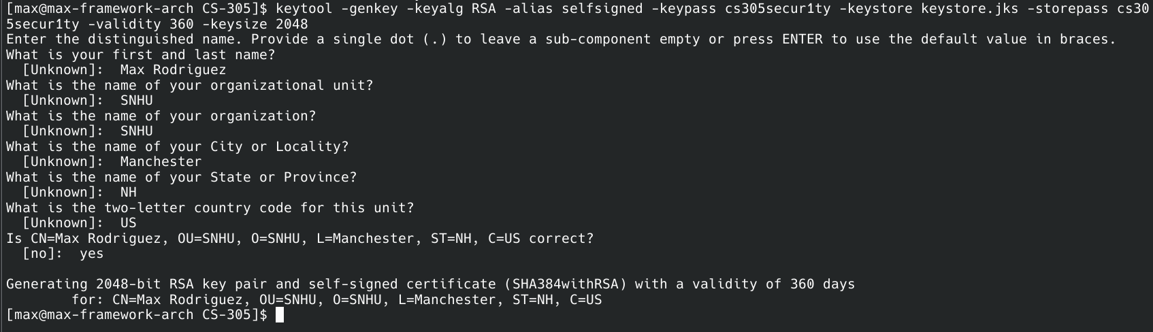

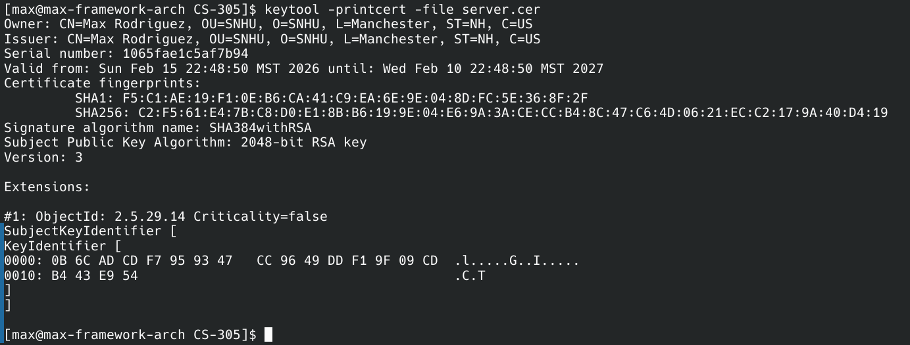

Deploy Cipher
Insert a screenshot below of the checksum verification.

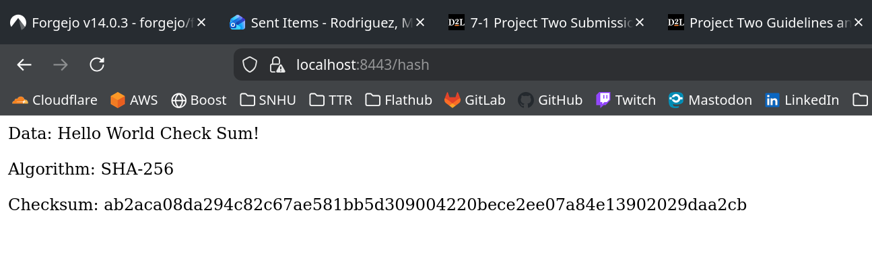

Secure Communications
Insert a screenshot below of the web browser that shows a secure webpage.

NOTE ^^^ it is secure, just my browser freaks out over the self-signed certificate. You probably already know. :P

Secondary Testing
Insert screenshots below of the refactored code executed without errors and the dependency-check report.

Screenshot of refactored code:
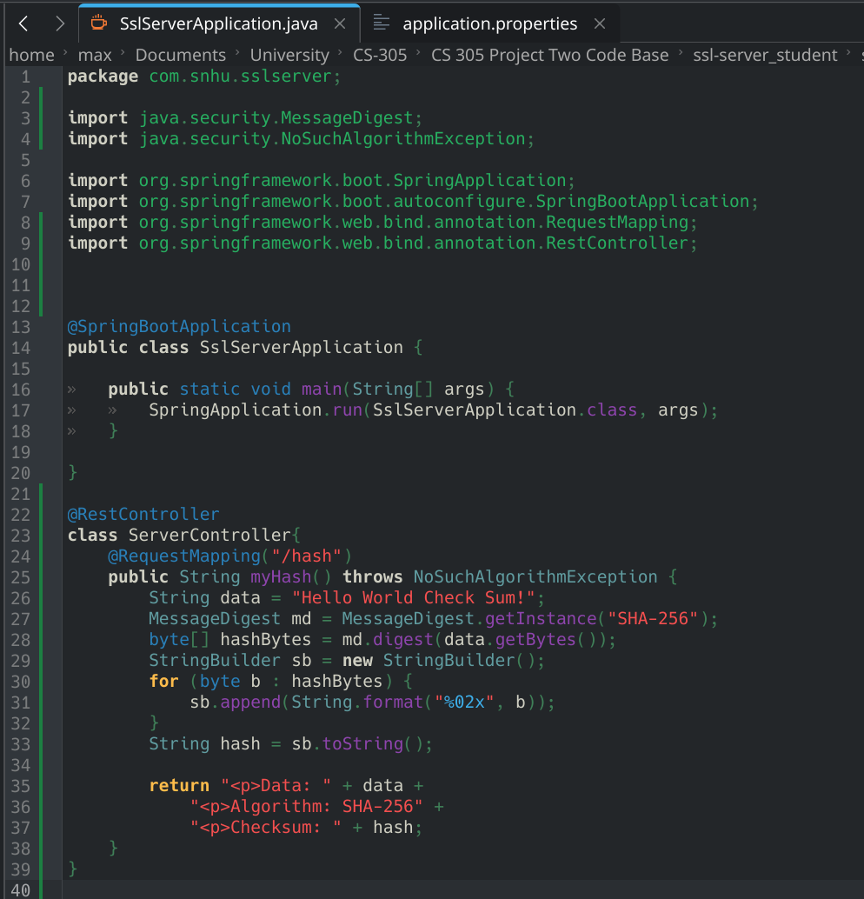
Screenshot proof of execution with no errors:
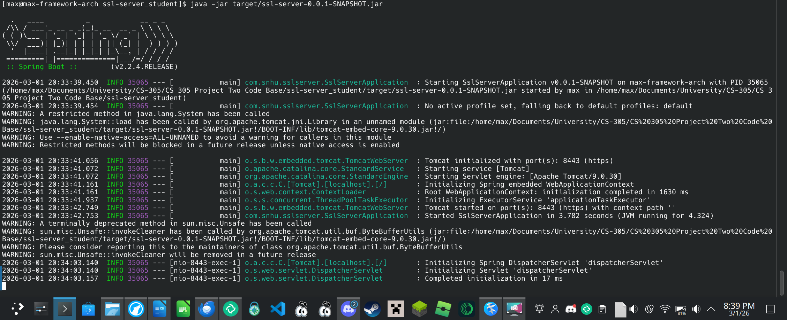

Dependency check report HTML screenshot:

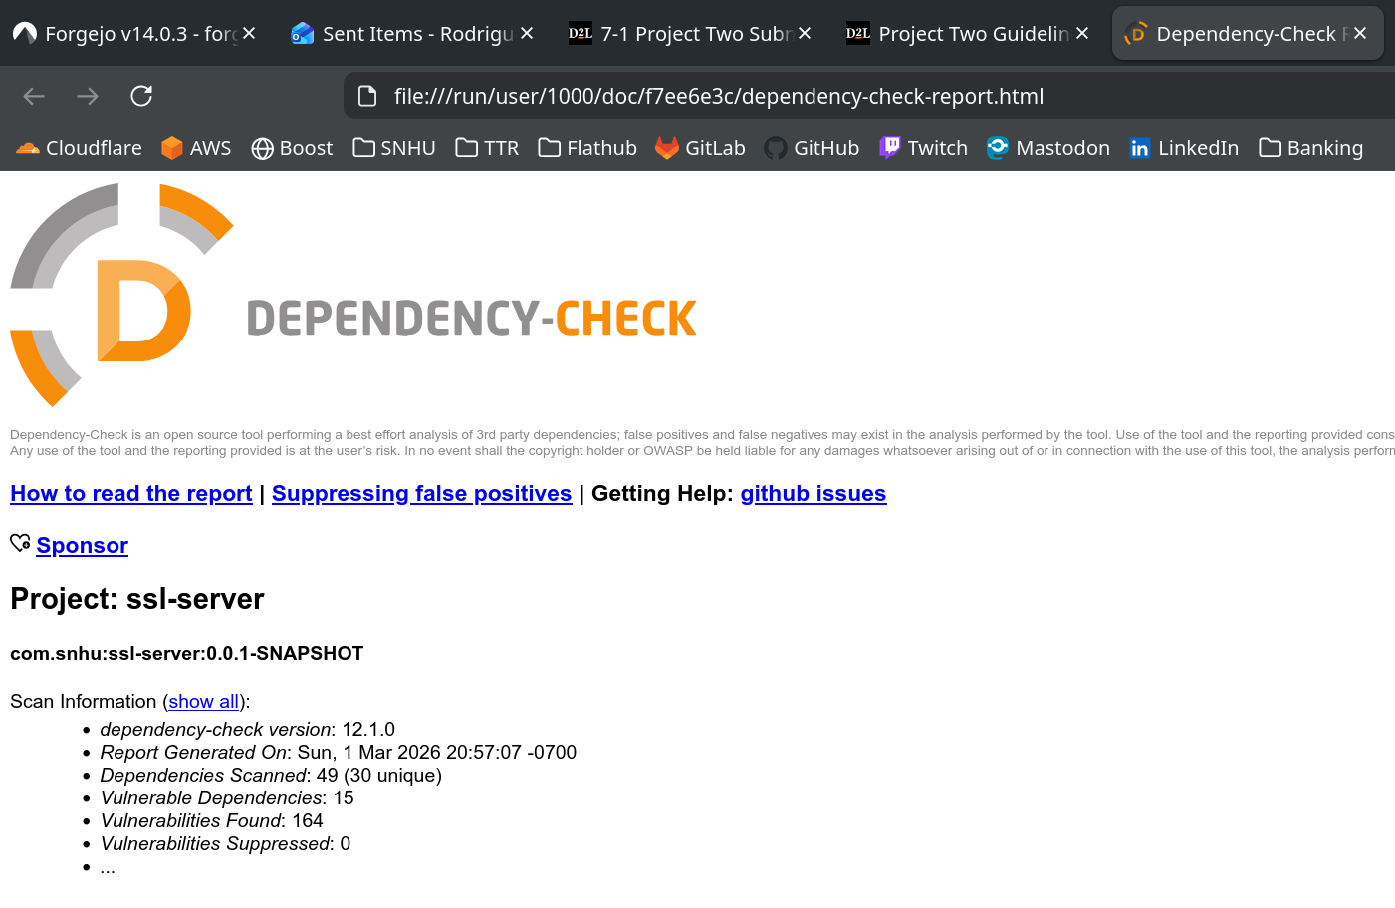

Functional Testing
Insert a screenshot below of the refactored code executed without errors.

Summary

The application was refactored to improve:

- Secure communication (HTTPS)
- Certificate management (self-signed RSA certificate)
- Dependency security validation

Refactoring addressed:

- Encryption layer
- Transport layer security
- Static vulnerability testing
- Secure coding practices
- Security was added in layers:
- Hashing
- TLS encryption
- Certificate authentication
- Static dependency scanning
- Manual code review

Industry Standard Best Practices

Best practices applied:

- Used SHA-256 instead of MD5/SHA-1
- Using HTTPS
- Used 2048-bit RSA keys
- Avoided hardcoded secrets
- Performed static vulnerability scanning

